Eritrea

## Freedom House political status

The data set shows the Freedom House political scores and status of the country each year.

## # A tibble: 19 x 5  
## country iso3c date mean status   
## <chr> <chr> <dbl> <dbl> <chr>   
## 1 Eritrea ERI 1996 5 Partly Free  
## 2 Eritrea ERI 1998 5 Partly Free  
## 3 Eritrea ERI 2000 6 Not Free   
## 4 Eritrea ERI 2002 6.5 Not Free   
## 5 Eritrea ERI 2003 6.5 Not Free   
## 6 Eritrea ERI 2004 6.5 Not Free   
## 7 Eritrea ERI 2005 6.5 Not Free   
## 8 Eritrea ERI 2006 6.5 Not Free   
## 9 Eritrea ERI 2007 6.5 Not Free   
## 10 Eritrea ERI 2008 6.5 Not Free   
## 11 Eritrea ERI 2009 7 Not Free   
## 12 Eritrea ERI 2010 7 Not Free   
## 13 Eritrea ERI 2011 7 Not Free   
## 14 Eritrea ERI 2012 7 Not Free   
## 15 Eritrea ERI 2013 7 Not Free   
## 16 Eritrea ERI 2014 7 Not Free   
## 17 Eritrea ERI 2015 7 Not Free   
## 18 Eritrea ERI 2016 7 Not Free   
## 19 Eritrea ERI 2017 7 Not Free

## Freedom House classification of political change

The data set shows the GDP growth and the ecomic growth classification of the country each year.

## # A tibble: 19 x 4  
## country iso3c date politicalChangeFH  
## <chr> <chr> <dbl> <chr>   
## 1 Eritrea ERI 1996 no change   
## 2 Eritrea ERI 1998 no change   
## 3 Eritrea ERI 2000 no change   
## 4 Eritrea ERI 2002 no change   
## 5 Eritrea ERI 2003 no change   
## 6 Eritrea ERI 2004 no change   
## 7 Eritrea ERI 2005 no change   
## 8 Eritrea ERI 2006 no change   
## 9 Eritrea ERI 2007 no change   
## 10 Eritrea ERI 2008 no change   
## 11 Eritrea ERI 2009 autocratization   
## 12 Eritrea ERI 2010 no change   
## 13 Eritrea ERI 2011 no change   
## 14 Eritrea ERI 2012 no change   
## 15 Eritrea ERI 2013 no change   
## 16 Eritrea ERI 2014 no change   
## 17 Eritrea ERI 2015 no change   
## 18 Eritrea ERI 2016 no change   
## 19 Eritrea ERI 2017 no change

## Freedom House score trend

The plot shows the Freedom House scores trend of the country.

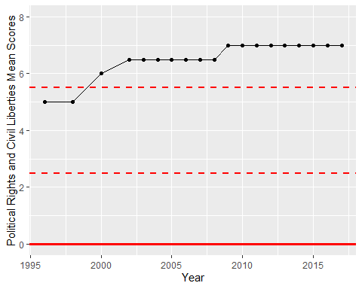

Freedom House Score Trend